**VISVESVARAYA TECHNOLOGICAL UNIVERSITY**

Jnana Sangama, Belagavi – 590014

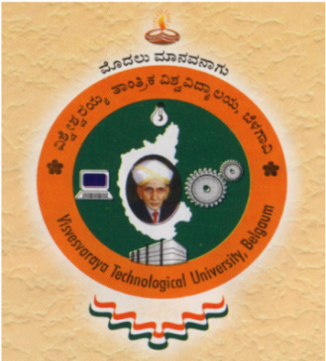

**Seminar Report on**

**“Unmanned Aerial Vehicle Object Detection and Recognition using Deep Learning”**

*Submitted in the partial fulfillment of the requirements for the award of the Degree of*

***Bachelor of Engineering in Computer Science and Engineering***

Submitted by

|  |  |
| --- | --- |
| **Darshika B** | **1VA18CS009** |

Under the support and guidance of

**Prof. Sreelatha P K**

**Assistant Professor,**

**Dept. of CS&E, SVIT**



**DEPARTMENT OF COMPUTER SCIENCE & ENGINEERING**

**(Accredited by NBA, New Delhi)**

**SAI VIDYA INSTITUTE OF TECHNOLOGY**

(Affiliated to VTU, Belgaum, Approved by AICTE, New Delhi and Govt. of Karnataka)

Rajanukunte,Bengaluru-560064

Tel: 080-2846 8196, Fax: 2846 8193 / 98, Web: saividya.ac.in

**2021-22**

**SAI VIDYA INSTITUTE OF TECHNOLOGY**

(Affiliated to VTU, Belgaum, Approved by AICTE, New Delhi and Govt. of Karnataka)

Rajanukunte,Bengaluru-560064

Department of Computer Science and Engineering

**(Accredited by NBA, New Delhi)**



**Certificate**

Certified that the Technical Seminar (17CSS86) entitled **“Unmanned Aerial Vehicle Object Detection and Recognition using Deep Learning”** was presented by **Darshika B (1VA18CS009)**, a bonafide student of Sai Vidya Institute of Technology, Bangalore, in partial fulfillment for the award of Bachelor of Engineering in Computer Science and Engineering of Visvesvaraya Technological University, Belagavi during the year 2021-2022. It is certified that all corrections/suggestions indicated for Internal Assessment have been incorporated in the report. The seminar report has been approved as it satisfies the academic requirements in respect of seminar work prescribed for the said degree.

**Prof. Sreelatha P K Dr. Shantakumar B Patil Dr. H S Ramesh Babu**

Assistant Professor Professor & Head Principal

Dept. of CS&E Dept. of CS&E